2024-25 Change Our Game Community Activation Grants Program
Application Questions and Guidance Document
Stream 3: Community Leaders

This document will assist you to prepare the information required to apply for funding.
Outlined in this document are:
- tips to submit your application online through the DJSIR Grants Portal
- the questions you will be asked on the application form; and
- the details you will need to provide in the application form
Applicants must submit a completed application online via the DJSIR Grants Portal before 5pm on Wednesday 26 February 2025. Please do not submit this document as your application.

Contents
Starting an application 2
SECTION 2: ELIGIBILITY 3
SECTION 3: NATIONAL REDRESS SCHEME 5
SECTION 4: APPLICANT ORGANISATION DETAILS 6
SECTION 5: AUTHORISED REPRESENTATIVE 8
SECTION 6: CANDIDATE DETAILS 9
SECTION 7: ACTIVITY DETAILS 10
SECTION 8: ASSESSMENT CRITERIA 11
SECTION 9: BANK ACCOUNT DETAILS 12
SECTION 10: SUPPORTING DOCUMENTS 13
SECTION 11: CONDITIONS OF GRANT 13
SECTION 12: DECLARATION AND ACKNOWLEDGEMENT 14
Troubleshooting and Tips for Completing Your Application 15
Appendix I - Community Activation Grants Program Acquittal Report 16

Starting an application  To start an application, visit the Change Our Game Community Activation Grants Program webpage  Find the Apply Now section, then select the link relating to the Stream you wish to apply for. | 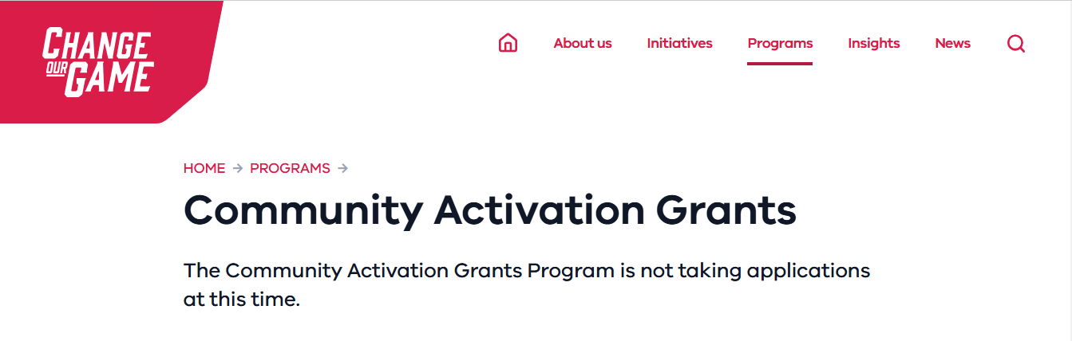
User Registration and Log In  You will need to log in to the DJSIR Grants Portal  - If you’re already a registered user, you’ll be directed to enter your username and password  - If you’ve forgotten your password, you can click on the Forgot Password link on the Log In page  - If you’re not a registered user, you’ll need to select the Create an Account link | 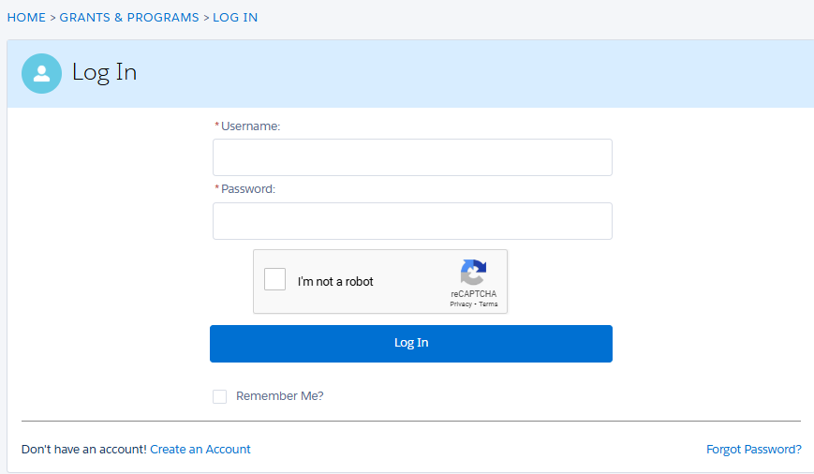
Save as Draft  We strongly encourage you to save your application regularly and draft responses in a separate document to prevent information loss, especially in case of technical issues.  Click Save as Draft before closing your web browser.  Once you’ve saved your draft application, you will receive a confirmation email with a link to your draft application and a unique Grant Application (GA) number.  To return to your draft application, click on the link in the email, or log back in to your DJSIR Grants Portal account: https://businessvic.secure.force.com/GrantsPortalLogin. | 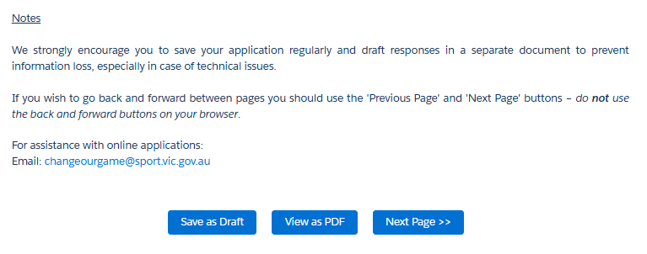  
Submit your application  Make sure you have provided all information and attachments required.  To finish your application, click Save and Preview followed by Save and Submit before 5pm on Wednesday 26 February 2025.  Once you’ve saved and submitted your application, you will receive a confirmation email.  For your reference, keep the email, GA-number and save a PDF copy of your application. | 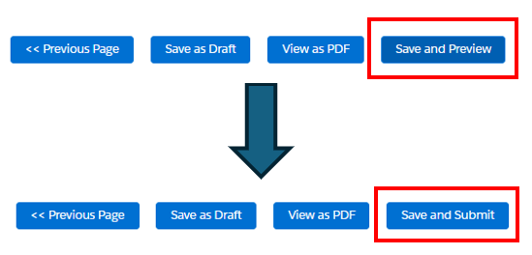

SECTION 2: ELIGIBILITY
In this section, applicants will answer questions about the eligibility of the organisation and Candidate to apply for funding through this program. Only applicant organisations and candidates who meet eligibility requirements will be able to progress and submit their application.
Please read the 2024-25 Change Our Game Community Activation Grants Program Guidelines to check your organisation and nominated candidate’s eligibility.
Question | Your answer
1. I have read Section 2.1 – Eligible Applicants and 2.3 – Eligible Candidates in the Change Our Game Community Activation Grants Program Guidelines and confirm my organisation and the candidate are eligible to apply for this program. | Tick Yes or No.  Head to the 2024-25 Change Our Game Community Activation Grants Program website to access a copy of the guidelines.
Authorisation  Confirm here to acknowledge you have authority to complete the form on behalf of the eligible club/organisation? | Tick Yes or No.  The individual completing the application must have approval to complete the application on behalf of the club/organisation.
2. My organisation holds an active Australian Business Number (ABN) | Tick Yes or No.  If unsure, search for your club/organisation’s legal name via the ABR website: https://abr.business.gov.au/
I will upload my Statement by Supplier form in Section 10 - Supporting Documents area | If your club/organisation does not have an ABN you will need to download, complete and submit a Statement by Supplier form in Section 10 Supporting Documents of your application to remain eligible.  Download the form here: https://www.ato.gov.au/forms-and-instructions/statement-by-supplier-not-quoting-an-abn  How to fill in the ATO Statement by Supplier form:  Section A: Supplier details - provide your club/organisation’s name and address.  Common responses to why the club/organisation doesn’t have an ABN:  - The supply is made by an individual or partnership without a reasonable expectation of profit or gain.  - The supplier is not entitled to an ABN as they are not carrying on an enterprise in Australia.  Section B: Declaration - provide an authorised person’s name, signature and date.
3. My organisation is a non-state or federal government, not-for-profit incorporated body. It is registered as either:  - an incorporated association; or  - a public company limited by guarantee. | Tick Yes or No.  If "No" is selected, the application cannot proceed.
4. If applicable, my organisation/affiliated sport and recreation governing body, has achieved a minimum of 40 per cent women on their board or has an Office for Women in Sport and Recreation approved action plan to meet this requirement? | This eligibility question is only relevant to recognised Victorian State Sporting Associations, State Sport and Active Recreation bodies and National Sporting Organisations without a recognised Victorian state body, as well as affiliated community associations leagues or clubs.  For more information visit Change Our Game - Balance the Board Policy.  Tick Yes, No, or N/A if the policy does not apply to your club/organisation.
5. If applicable, my organisation has completed reporting requirements (e.g. submitted grant acquittals) for previous Change Our Game grants | This eligibility question is only relevant to clubs/organisations that have been awarded a grant through a Change Our Game program before.  Tick Yes if your club/organisation has completed reporting requirements (submitted acquittal documentation) for Change Our Game grants.  Tick No, if your club/organisation has received a Change Our Game grant(s) previously but has not completed reporting requirements (submitted acquittal documentation) for the grant(s). For support, please contact ChangeOurGame@sport.vic.gov.au if required.  Tick N/A if your club/organisation has not previously had reporting requirements for Change Our Game grants.
6. My organisation received a grant in the 2023-24 Change Our Game Community Activation Grants Program | Tick Yes or No.  If your club/organisation was successful in receiving a grant for the 2023-24 program, you are not eligible to apply in this round.
7. My organisation received a grant under the Community Leaders Stream in the 2024-25 Change Our Game Professional Development Scholarships Program | Tick Yes or No.  If your club/organisation was successful in receiving a grant for the Community Leaders Stream in the 2024-25 Change Our Game Professional Development Scholarships Program, you are not eligible to apply in this round.
CANDIDATE ELIGIBILITY
Candidate Consent  The Candidate has consented to the supply of their personal information for the purposes of this application | Tick Yes or No.  This question asks whether the Candidate consents to sharing personal information for the purposes of this application. You must select "Yes" to proceed.  If "No" is selected, the application cannot proceed.
Does the Candidate meet the following eligibility criteria:  Does the Candidate identify as a woman? | The applicant should select "Yes" if they identify as a woman. If they do not identify as a woman, they should select "No." If "No" is selected, the application cannot proceed.  See section 2.3 Stream 3 – Eligible Candidates of the Program Guidelines for further details.
Does the Candidate live in Victoria? | Tick "Yes" if the Candidate resides in Victoria. If they do not live in Victoria, they should select "No."  If "No" is selected, the application cannot proceed.
Is the Candidate aged 18 years or over? | Tick "Yes" if the Candidate is 18 years of age or older. If they are under 18, they should select "No."  If "No" is selected, the application cannot proceed.
Is the Candidate currently in a volunteer role in a community sport and active recreation club, association or organisation? | Tick "Yes" if the Candidate is currently volunteering in a community sport or active recreation setting. If they are not volunteering in such a role, they should select "No."  Volunteers are those involved in non-playing roles as a volunteer, or who consider themselves a volunteer even if they receive some form of compensation.  If "No" is selected, the application cannot proceed.
Did the Candidate receive a grant under the Community Leaders Stream in the 2024-25 Change Our Game Professional Development Scholarships Program? | Tick "Yes" if the Candidate received a grant under the Community Leaders Stream of the 2024-25 Professional Development Scholarships Program. If they were not successful, they should select "No."  If "Yes" is selected, the application cannot proceed.

SECTION 3: NATIONAL REDRESS SCHEME
This section asks applicants to disclose whether their organisation was named in the Royal Commission into Institutional Responses to Child Sexual Abuse, or has been notified of being named in an application for redress under the National Redress Scheme.
Refer to section 2.5, Child Safety Requirements, in the program guidelines for more details.
Question | Your answer
Has your club/organisation been named in an application or received a Notice of Redress Liability? | Tick Yes or No.  If you select Yes, proceed to provide the relevant details in the following fields.
Date your club/organisation was named in an application or Notice of Redress Liability" | Enter the date in the format DD/MM/YYYY.  If applicable, provide the specific date your club/organisation was named.
Has your club/organisation joined the scheme? | Tick Yes or No.  If you select No, explain the reason in the next field.
Date your club/organisation joined the Scheme: | If applicable, provide the date your club/organisation joined the Scheme in the format DD/MM/YYYY.
Why has your club/organisation not joined the scheme? | Provide a brief explanation in the text box below, if applicable.
Does your club/organisation intend to join the Scheme? | Tick Yes or No.  If you select Yes, please provide the intended date in the following field.  If the club/organisation does not intend to join the scheme, the application cannot proceed.
Date by which your Club/Organisation intends to join the Scheme: | If you intend to join the Scheme, provide the intended date in the format DD/MM/YYYY.

SECTION 4: APPLICANT ORGANISATION DETAILS
This section requires applicants to provide key information about their organisation, including its legal name, contact details, and relevant registration or accreditation details.
Question | Your answer
Name of Applicant Organisation: | Provide the full legal name of your organisation as registered.
Type of Organisation | Select the option that best describes your organisation from the list below:  1. Community sport and recreation club, association or organisation  2. Regional sports assembly  3. Local government authority  4. State sporting association, state sporting organisation, or peak body recognised by Sport and Recreation Victoria  5. National sporting organisation recognised by the Australian Sports Commission (if no state body exists)  6. Aboriginal Community Controlled Organisation (ACCO) and incorporated Aboriginal association
Incorporation Registration Number or Australian Company Number: | Enter the 9-digit Incorporation Registration Number (for incorporated associations), 4-digit number for Indigenous Corporations or the 9-digit Australian Company Number (for companies).  You can check these numbers on these sites:  - Incorporated Associations Register  - Aboriginal and Torres Strait Islander Corporations Register  - ASIC Register
Australian Business Number (ABN):  Check the ABN at ABN Lookup | Enter your ABN number.  If you don’t have an ABN, please upload a Statement by Supplier as a supporting document to your application.  You can check your ABN on the ABN Lookup.  Entity Name:  - Enter the full legal name of your organisation as it appears on your official records.  ABN Status:  - This will automatically be filled based on your ABN information.  Entity Type:  - This will automatically be filled based on your ABN information.  Is your organisation registered for GST?  - Select "Yes" if your organisation is registered for Goods and Services Tax (GST), or "No" if it is not.  GST Registered Date:  - This will automatically be filled based on your ABN information.
Organisation Registered Address | Enter the full address of where your club/organisation is legally registered.  Required fields: Country, Street Address, Town/Suburb, State, Postcode
Postal address same as address above?  Organisation Postal Address | Select "Yes" if your postal address is the same as the registered address. If not, select "No" and enter your postal address below.  Organisation Postal Address:  Enter the address where you receive mail if it differs from the registered address.  Required fields: Country, Street Address, Town/Suburb, State, Postcode
Organisation LGA | Select the correct LGA from the dropdown menu.
Sport Type | Please select between 1 and 3 sports that align with the club/organisation's focus. If it's more than this, please select 'all sports'.  Avoid selecting multiple sports, as this may cause issues with form submission.

SECTION 5: AUTHORISED REPRESENTATIVE
This section requires applicants to provide information about the application’s Authorised Representative.
The Authorised Representative must be appointed by your club/organisation to:
- submit this application; and
- acknowledge the Email of Acceptance (if the application is successful) and be contacted by the Office for Women in Sport and Recreation regarding the outcome of the application.
The Candidate and the Authorised Representative cannot be the same person.
Question | Your answer
Title: | Select your title from the dropdown menu.  Please enter None or N/A in the text box available below if not applicable.
First Name:  Last Name: | Enter your first name in the text box.  Enter your last name in the text box.
Position with the organisation: | Enter your current position or role within the club/organisation in the text box.
Telephone:  Mobile: | Enter your telephone number, including the country code (+61), followed by your phone number. Please do not use spaces, special characters, or leading zeroes.  Enter your mobile phone number, including the country code (+61), followed by your phone number. Please do not use spaces, special characters, or leading zeroes.
Email: | Enter your email address in the text box.
Please consider using a shared inbox as your club/organisation’s contact email to ensure ongoing communication in case of any personnel changes.
The Office for Women in Sport and Recreation will communicate with applicants through this email address. Please ensure it is accurate and active.

SECTION 6: CANDIDATE DETAILS
This section collects information about the individual who will undertake the grant activity (the Candidate). Please note:
- The Candidate and the Authorised Representative cannot be the same person.
- If demographic information is provided, ensure you have the Candidate's consent to share their personal details.
- The information in this section will help assess eligibility and provide insights into representation from under-represented groups. Refer to Section 3.1: Under-represented Groups and Section 5.5: Assessment Criteria in the Program Guidelines for more details.
Note: If the Candidate is currently employed by an eligible organisation and is seeking funding for professional development to support that employed role, their application is ineligible. This is outlined in Section 2.4 of the program guidelines: Stream 3 – Ineligible Candidates. The professional development opportunity must align specifically with the Candidate’s role as a volunteer.
Question | Your answer
Title: | Select your title from the dropdown menu.  Please enter None or N/A in the text box available below if not applicable.
First Name:  Last Name: | Enter the Candidate’s first name in the text box.  Enter the Candidate’s last name in the text box.
Pronouns: | Enter the Candidate’s pronouns in the text box.  Examples: she/her, he/him, they/them
Organisation: | Enter the organisation name the Candidate volunteers with, in the text box.
Position: | Enter the Candidate’s current position or role within the club/organisation in the text box.
Sport type  Indicate which sport/s the Candidate is associated with: | Please select between 1 and 3 sports that align with the club/organisation's focus. If it's more than this, please select 'all sports'.  Avoid selecting multiple sports, as this may cause issues with form submission.
Telephone: | Enter the Candidate’s telephone number, including the country code (+61), followed by your phone number. Please do not use spaces, special characters, or leading zeroes.
Email: | Enter the Candidate’s email address in the text box.
Demographic information: | Consent: If submitting on behalf of the Candidate, ensure their consent to share demographic details.  Enter the Candidate’s current residential town/suburb in the text box.  Select the correct LGA from the dropdown menu.  Tick "Yes" for any under-represented groups the Candidate identifies as, including:  - Aboriginal or Torres Strait Islander origin  - Culturally and Linguistically Diverse (CALD) community  - with disability  - the LGBTIQA+ community  There is no option to tick “No” for these demographic questions.

SECTION 7: ACTIVITY DETAILS
This section requires applicants to provide details about the activity the Candidate will undertake with the grant funding.
Note: We strongly encourage you to check section 3.4 of the program guidelines: Types of activities and expenditure that will not be funded, to make sure the activity is eligible for funding.
Question | Your answer
Activity Name: | Enter the title or name that best represents the professional development training/activity you're applying for funding to support.  This section has a limit of 30 words.
Activity Description: | Provide a clear and concise description of the professional development training/activity that the Candidate will undertake.  This section has a limit of 50 words.
Activity Start Date:  Activity Completion Date: | Indicate when the activity will begin and when the activity is expected to be completed.  Provide the intended dates in the format DD/MM/YYYY.  Start dates for activities should not be earlier than May 2025, following announcement of successful applications for this round of the program.
Amount requested from this program (ex GST) | Enter the specific dollar amount you are requesting, within the range of your selected funding level.  This amount must not exceed $5,000.  Please attach evidence of activity cost to the Supporting Documents at section 10 of this application form.

SECTION 8: ASSESSMENT CRITERIA
This section asks applicants to describe the proposed activity for the Candidate and how it aligns with the program’s goals and outcomes.
It includes questions about the activity's scope, impact, and alignment with specific program outcomes, as well as details on benefits for under-represented groups and efforts to promote and elevate women and girls.
Question | Your answer
- Please describe your (or the Candidate’s) current position in the sport and active recreation sector, any previous relevant volunteer or work experience and how the proposed activity will benefit the Candidate. | Start by describing the Candidate’s current role in the sport and active recreation sector. Mention what their main tasks are, and how they support the community.  Include details of any past volunteer or work experience in sport or recreation that is relevant. Focus on roles that show the Candidate’s commitment or skills in this area.  Explain how the professional development opportunity will help the Candidate. Think about how it will improve their skills, knowledge, and ability to contribute as a volunteer.
- Please select one or more of the following Program outcomes that your activity will support:  - increased participation by women and girls in community sport and active recreation  - enhanced understanding of gender equity practices within community sport and active recreation organisations  - more women in leadership roles in community sport and active recreation  - promotion and elevation of women and girls in sport and active recreation  Please detail how the proposed activity supports one or more of the Program outcome(s) (selected above) and demonstrates value for money: | Review the list of program outcomes and select all that apply.  In the text box, explain how your activity aligns with the selected outcome(s).  - Provide examples to demonstrate impact.  - Highlight how the activity delivers value for money by achieving the program goals.
- Please detail how the activity will support and benefit the applicant club or organisation, including its commitment to gender equality and levelling the playing field for women and girls in sport and active recreation. | Describe how the activity aligns with your club/organisation’s values and long-term objectives.  Explain how this professional development opportunity will help the club/organisation grow or improve.  Highlight specific ways the activity will support gender equality and create more opportunities for women and girls in sport and recreation.  Describe the positive changes or outcomes the activity will bring to the club/organisation.  Focus on how the activity will make a lasting impact, such as new skills, better programs, or stronger community involvement.
4. Does the Candidate identify as someone from an under-represented group (as noted in Demographic area of Section 6 in the application)?  Please detail how the activity aims to benefit people from under-represented groups | Tick Yes if applicable.  Use the text box to describe how your activity will support these groups.
5. Please detail in what way the activity aims to promote and elevate women and girls in community sport and active recreation? | Explain how the activity will increase visibility and recognition for women and girls in sport.  Include details on promotional efforts, leadership opportunities, or pathways for advancement. Refer to Section 3.2 of the program guidelines.

SECTION 9: BANK ACCOUNT DETAILS
This section asks for your organisation's bank account details to facilitate grant payment if your application is successful. Please provide accurate details as they appear on your organisation's bank statement. Do not provide personal bank account details or create an invoice for this transaction.
Important Notes:
- If your application is successful, the department will send an Email of Acceptance to your organisation's authorised representative. Payment will only be processed after acknowledging the email.
- Payments will be made to the nominated bank account of the applicant organisation. Personal bank account details must not be provided.
- Organisations not registered for GST will receive payments exclusive of GST. For organisations registered for GST, GST will be applied to the grant payment.
Question | Your answer
Bank Name: | Enter the name of the bank as it appears on your organisation’s bank statement.
Bank Account Name: | Provide the name of the bank account. Do not enter the name of the bank or financial institution.
BSB: | Enter the six-digit BSB number without spaces or commas.
Account Number: | Enter the account number without spaces or commas.
I acknowledge and accept that as the Applicant I am solely responsible for the accuracy of the bank account details and that the provision of incorrect bank account details may delay the processing of the application and/or not receiving payment. | Tick the box to confirm you understand that your organisation is solely responsible for the accuracy of the bank account details provided. Inaccurate details may delay payment or result in not receiving funds.

SECTION 10: SUPPORTING DOCUMENTS
This section requires applicants to upload the necessary documents to support their application.
General Instructions
- File Requirements: Ensure each attachment is in the correct file format (e.g., MS Word, MS Excel, PDF, PNG or JPEG) and no larger than 5MB.
- Naming Your Files: Clearly label each file to reflect its content (e.g., "Professional Development Training_ClubName.pdf").
- Submitting by email: If you cannot attach files here, email them to ChangeOurGame@sport.vic.gov.au with your application number in the subject line so we can find the record to upload the file.
Supporting Documents Checklist  Please upload the following files, if applicable: | - Letter of Support for the Candidate: Provide a letter from a representative of the club, association, or organisation supporting the Candidate's application.  - Training Company and/or Course Information: Submit the website link or brochure for the training company or course. This should include the cost of the course as evidence to support the application.  - National Redress Scheme Evidence (if applicable): Submit documentation verifying your organisation’s participation.
Additional Support Documents via URL  If relevant, you may also include links to additional supporting documents: | - URL 1: Enter the hyperlink to the additional document.  - URL 2: Enter the hyperlink to the additional document.  - URL 3: Enter the hyperlink to the additional document.

SECTION 11: CONDITIONS OF GRANT
This section outlines the conditions that apply to successful grant applicants. It is important to carefully read and understand these terms as they form the basis of your agreement if your application is successful.
If you have any questions or require clarification about these conditions, contact the Office at ChangeOurGame@sport.vic.gov.au.
Please review the conditions of the grant outlined in this section.
There are no questions to respond to in this section. However, you must ensure that you agree to and can comply with the conditions if your application is successful.
This section outlines the acquittal requirements as part of the grant agreement. For your convenience, the acquittal report questions have been included as an appendix in this document.

Scroll to the bottom of the page and hit “Next Page” to continue with your application.

SECTION 12: DECLARATION AND ACKNOWLEDGEMENT
This section requires applicants to read, agree to, and accept the declarations as part of the application process. Applicants must confirm their agreement to the program terms and provide their details before submitting.
Declaration | Your answer
You must accept the declaration prior to submitting your application.  By checking the box below, I confirm that I am making the above declarations and acknowledgments and agree on behalf of the Applicant organisation to all terms of the Program as set out in the Conditions of Grant, Program Guidelines and my Application. | To confirm your acceptance, check the box provided below the declaration statement.  By doing so, you are officially agreeing to the declaration and acknowledging that you accept all program terms on behalf of the applicant.
Question | Your answer
Name: | Enter your full legal name
Position: | Enter your position within the applicant organisation
Date: | Select today’s date from the calendar
Save and Preview | Click Save and Preview  Please review the information to ensure completeness and accuracy before submitting.
Save and Submit | Click Save and Submit  A confirmation message will be displayed and emailed.  If you do not receive this message, please follow the troubleshoot options below and/or contact us at: ChangeOurGame@sport.vic.gov.au.

Troubleshooting and Tips for Completing Your Application
To ensure a smooth application process, please consider the following guidance:

- Browser Compatibility
For the best experience, we recommend using Google Chrome to complete your application. The form may not function properly in browsers such as Microsoft Edge or Safari.
- Device Compatibility
The application portal is optimised for use on laptops or desktop computers. Using an iPad or iPhone may result in functionality issues.
- Session Timeout
As a security measure, the portal will automatically log you out after 30 minutes of inactivity. To avoid losing your work, it is highly recommended that you save your work regularly and draft your responses to the assessment criteria in a separate Word document. Once finalised, you can copy and paste your answers directly into the application form.
- Resolving Submission Errors
If you encounter an error message stating your application could not be submitted, follow these steps:
- Navigate to the Grants & Programs page and locate your draft application.
- Open the draft and select Save as Draft.
- This will close the application, follow step 1 above to reopen it.
- Select Save and Preview, then Save and Submit.
Following this process should resolve the issue and allow your application to be successfully submitted.
If you experience ongoing difficulties, please contact ChangeOurGame@sport.vic.gov.au for assistance.

Appendix I - Community Activation Grants Program Acquittal Report
List of acquittal questions
SECTION 1 - Introduction
This report is a key acquittal requirement of the Office for Women in Sport and Recreation Change Our Game Community Activation Grants Program.
The funded activity must be completed within 18 months following execution of the funding agreement.
The purpose of the acquittal report is for you to provide a summary of key outcomes and learning’s from your activity and to assess the impact of the grant on yourself and your club/community. Information from this report may be used to identify potential case studies and inform future planning and improvements to Change Our Game grant programs.
It is a requirement under the funding agreement between your organisation and the Department of Jobs, Skills, Industry and Regions, that evidence of the Recipient’s completion of the Project, such as tax receipts and financial reports, be submitted as part of this acquittal report. Recipients are also required to sign a statutory declaration and Certificate Identifying Exhibit in relation to expenditure of the funds (section 4 of the acquittal form).
Your details
Name:
Organisation:
Program:
Activity name:
Our Ref:
Total grant amount:
Dates activity was completed:
SECTION 2 - Grant Benefits and Participation Outcomes
Please answer the following questions
- Describe your community activation activity (max 250 words)

- Did your activity support one or more of the following program outcomes (please select all that apply):

- Increased participation by women and girls in sport and active recreation
- Increased understanding of gender equity practices, including gender equitable access and use of community sports infrastructure
- Celebration and elevation of women and girls in sport and active recreation

2a. Is your organisation / club continuing or planning to continue the activity?
Please provide further details to your response above:

2b. Please describe how this activity enhanced knowledge of gender equity within your club/organisation

2c. What was the key focus of this activity? Who was being celebrated within the club/organisation?

- Please describe any other ways the activity has supported the organisation / club's commitment to gender equality and levelling the playing field for women and girls in sport and active recreation

- How do you plan to maintain / build on your activity to continue to support and celebrate the role of women and girls at your organisation / club?

- How many people participated in the activity, please provide as accurate information as possible for the following demographic questions:

- Total number of participants
- Total number of women and girls
- Total number of Aboriginal and Torres Strait Islanders
- Total number of people with Disability

Of the total number of women and girls who participated, please estimate the total number who identify as:

- Aboriginal and Torres Strait Islanders
- Culturally and linguistically diverse (CALD) communities
- People with a disability
- Regional and rural communities
- LGBTIQ+ community
- Describe what changes to participation have occurred at your organisation / club as a result of the activity?

- Participation increased
- Participation was maintained
- Participation decreased
If participation increased or decreased, please indicate the number of additional/less participants (if participation decreased, please include a '-' sign before the number)

Why did participation change?

- Has this grant opportunity supported your organisation / club in working towards achieving gender equality?

Please describe why

- In your experience of participating in the program, please rate your response to the following questions.
The next 3 questions will ask you to rate your response on a scale from 1 to 5.
Ratings are defined as follows:
1 - Not at all
2 - Very little
3 - Somewhat
4 - To a great extent
5 - Completely

      - To what extent has this program increased participation opportunities for Victorian people.

      - To what extent has this program increased participation opportunities for people with disability?

      - To what extent has this program increased participation opportunities for Aboriginal and Torres Strait Islanders?

SECTION 3 - Sharing the Stories & Project Reflections
- Was there any news or social media coverage of your event/activity? If so, how many articles/posts were there? Please attach examples of articles or social media coverage
Number of media articles:
Number of social media posts:
Other communications and or media coverage (number and description):
- Please outline the top three areas that would further support your organisation / club to increase participation and enhance gender equality for women and girls
Area 1:
Area 2:
Area 3:
- Is there anything else you would like to share with us? E.g. Interesting stories or learnings, suggestions for future applicants etc.
Please attach photos with consent for use by the Department

- Please provide any additional comments / suggestions for improvement of the Community Activation Grants Program

SUPPORTING DOCUMENTS
Please attach any photos or links related to your Community Activation Grant project. Ensure that your attachments are of an acceptable file type (e.g., Word, Excel, PDF or JPEG) and do not exceed the maximum size of 5MB each. If you are unable to attach these documents, they may be emailed to ChangeOurGame@sport.vic.gov.au.
Ensure that you clearly name each document and include the application number in the subject line of your email.
Attachment 1 (max size 5 MB)
Attachment 2 (max size 5 MB)
Attachment 3 (max size 5 MB)
Attachment 4 (max size 5 MB)
Attachment 5 (max size 5 MB)
Internet Link 1
Internet Link 2
Internet Link 3
Internet Link 4
Internet Link 5
SECTION 4 - Declaration and Acquittal
Program:
Category:
Grant Recipient:
Project Name & Grant Amount:
Our Ref:
Declaration
It is a requirement under the funding agreement between your organisation and the Department of Jobs, Skills, Industry and Regions, that evidence of the Recipient's completion of the Project, such as tax receipts and financial reports, be submitted as part of this acquittal report. Recipients are also required to download, sign and upload a statutory declaration and Certificate Identifying Exhibit in relation to expenditure of the funds.
Below, you must attach documents that confirm payment of the grant funds used to-date. Acceptable documents include:
- receipts from suppliers/service providers;
- bank statements showing payments to suppliers/service providers; and,
- invoices showing a remaining balance.
Invoices/Financial statements *
Additional Attachment 1 (max size 5 MB)
Additional Attachment 2 (max size 5 MB)
I have attached the Statutory Declaration and Certificate Identifying Exhibit
I have attached financial records including invoices and receipt of payments confirming expenditure against the grant funds
I declare that the information contained in this Declaration is witnessed true and correct.
Name of Authorised Representative:
Date:

