Fair Access Policy Template
Supporting gender equitable access to and use
of community sports infrastructure in Victoria

Acknowledgements
The Office for Women in Sport and Recreation, Sport and Recreation Victoria, the Victorian Health Promotion Foundation (VicHealth) and the State of Victoria respectfully acknowledge the Traditional Owners of the land on which we work and play. We pay our respect to their Elders, past and present.
The Fair Access Policy Roadmap has been developed by the Office for Women in Sport and Recreation, Sport and Recreation Victoria and VicHealth in collaboration with many organisations. In particular, the contributions of the many local governments, state sporting bodies and other groups which took part in consultation to help shape this project are acknowledged:

AFL Victoria  Athletics Victoria  Ballarat City Council  Basketball Victoria  Campaspe Shire Council  Central Goldfields Shire Council City of Casey  City of Glen Eira  City of Greater Dandenong  City of Stonnington  Colac Otway Shire  Commission for Gender Equality in the Public Sector  Cricket Victoria  Department of Environment, Land, Water and Planning  Department of Health  Department of Families, Fairness and Housing | Department of Jobs, Precincts and Regions  East Gippsland Shire Council  Fencing Victoria  Football Victoria  Glenelg Shire Council  Hockey Victoria  Hume City Council  Indigo Shire Council  Lacrosse Victoria  Local Government Victoria  Macedon Ranges Shire Council  Maroondah City Council  Melton City Council  Mildura Rural City Council  Mooney Valley City Council  Moreland City Council  Mornington Peninsula Shire Council | Municipal Association of Victoria  National Rugby League Victoria  Netball Victoria  Parks Victoria  Regional Sport Victoria  Southern Grampians Shire Council  Sunraysia Community Health Services  Tennis Victoria  Towong Shire Council  Vicsport  Victorian Equal Opportunity and Human Rights Commission  Victorian Local Governance Association  Wellington Shire Council Wyndham City Council

The Fair Access Policy Template: For Local Governments and other public land management groups

Supporting the delivery of the Fair Access Policy Roadmap, this Fair Access Policy Template is provided for use by any local government organisation or other public land management group seeking additional guidance and support.
Organisations seeking additional guidance are encouraged to use this template as a starting point for developing a localised gender equitable access and use policy. The template can be adapted and edited as required.
Organisations are under no obligation to use this template to comply with the requirements of the Gender Equality Act 2020 or to complete the Fair Access Policy Roadmap.
As the Fair Access Policy Roadmap is implemented, revisions and updates to this template may be issued to this policy template from time to time.

Fair Access Policy for [insert name of your organisation]

- Purpose

- Background

- Statement of Intent

- Scope

- Policy Framework

- The Fair Access Principles

- Compliance and Monitoring

- Definitions

- Policy Authorisation

- Addendum: The Fair Access Action Plan template

1. Purpose
The Fair Access Policy (the Policy) seeks to address known barriers experienced by women and girls in accessing and using community sports infrastructure. The Policy aims to progressively build capacity and capabilities of [insert name of your organisation] in the identification, and elimination of systemic causes of gender inequality in policy, programs, communications, and delivery of services in relation to community sports infrastructure.
[Insert name of your organisation] will undertake take the necessary and proportionate steps towards implementation of the Fair Access Policy.

2. Background
Sport is a highly visible and valued feature of [insert name of your local government area]’s culture and identity. The sport and active recreation sector provide opportunities for enriching our communities through the promotion of respect and fair mindedness for all people, while also supporting the physical and mental wellbeing of all Victorians. [insert name of your organisation] is well positioned to design and implement place-based, integrated actions plans that progress gender equality in community sport.
The Victorian Government is committed to developing an environment for all Victorians to live in a safe and equal society, have access to equal power, resources, and opportunities, and are treated with dignity, respect, and fairness. A reform agenda has been developed to change the systems that have perpetuated gender inequality by designing an enduring structure that requires implementation and tracking of progress over time.
This reform agenda includes addressing the traditional structures and way community sport and recreation organisations operate through the implementation all nine (9) recommendations from the 2015 Inquiry into Women and Girls in Sport and Active Recreation. This includes recommendation six (6):
“…encourage facility owners and managers to review access and usage policies to ensure women and girls have a fair share of access to the highest quality facilities at the best and most popular times”
and
“facilitating a universal adoption of [policies, strategies and audit tools] will drive change further”
As a defined entity of the Gender Equality Act 2020, [insert name of your organisation] will be required from 31 March 2021 to conduct Gender Impact Assessments (GIA) on all new policies, programs, communications, and services, including those up for review, which directly and significantly impact the public (Gender Equality Act 2020). The access and use of community sports infrastructure is an example of policy that has a direct and significant impact on the public.

3. Statement of Intent
This Statement of Intent establishes the expectation that gender equality is considered and prioritised in all current and future [insert name of your organisation]’s planning, policy, service delivery and practice as they relate to community sports infrastructure.
- [insert name of your organisation] recognises that gender equality is the attainment of equal rights, responsibilities, and opportunities of women, men, trans and gender diverse people. Equality does not mean that women, men, trans and gender diverse people will become the same but that their rights, responsibilities, and opportunities will not depend on their gender.

- [insert name of your organisation] recognises that gender equity is the provision of fairness and justice in the distribution of benefits and responsibilities based on gender. The concept recognises that people may have different needs and power related to their gender and these differences should be identified and addressed in a manner that rectifies gender related imbalances.

4. Scope
The Policy enables effective and efficient integration of the requirements of the Gender Equality Act 2020, the Local Government Act 2020 and the Public Health and Wellbeing Act 2008 and other legislative frameworks.
The scope of the Policy is to support [insert name of your organisation] to take positive action towards achieving gender equity in the access and usage of community sports infrastructure. This complies with the Gender Equality Act 2020 and aligns with Municipal Public Health and Wellbeing Plans or Council Strategies:
Reform Agenda | Objectives
To support [insert name of your organisation] to take positive action towards achieving gender equity in the access and use of community sports infrastructure | To build capacity and capabilities of [insert name of your organisation] in the identification and elimination of systemic causes of gender inequality in policy, programs, communications, and delivery of services in relation to community sport and recreation.  To ensure an effective place-based response for the gender equitable use and access of community sports infrastructure.  To promote gender equality in policies, programs, communications, and services as they relate to community sports infrastructure.

For [insert name of your organisation], the Policy applies to the following community sports infrastructure:
- [Insert list of community sports infrastructure managed by your organisation]
 | Facility | Location
1
2
3
4
5
…

5. Policy Framework
The Policy is designed to comply with the Gender Equality Act 2020, and the wider Victorian Government gender equality strategy.
[insert name of your organisation] acknowledges:
  - the disadvantaged position some individuals have had in the sport and recreation sector because of their gender; and

  - that achieving gender equality will require diverse approaches for women, men, trans and gender diverse people to achieve similar outcomes for people of all genders.
[insert name of your organisation] will:
  - engage fairly and equitably with all staff, governance working groups, state sporting organisations, regional sport assemblies (where applicable) and members of our sport and recreation community, regardless of their gender, in a positive, respectful, and constructive manner; and

  - engage in the process of gender impact assessments to assess the implications for women, men, trans and gender diverse people of any planned action, including policies and communications. This is a strategy for making all voices, concerns and experiences, an integral dimension of the design, implementation, monitoring of policies and programs.

6. Fair Access Principles
The Fair Access Principles have been developed by the Office for Women in Sport and Recreation, Sport and Recreation Victoria and VicHealth, in consultation with representatives from local government and the state sport and recreation sector. This Policy and any resultant action plan are based on six (6) principles of inclusivity, full participation, equal representation, encouraging and supporting user groups, and prioritising user groups committed to equality.
[insert name of your organisation] considers that these principles provide clear direction, while also enabling adaption to the specific environment of [insert name of your organisation]’s area.
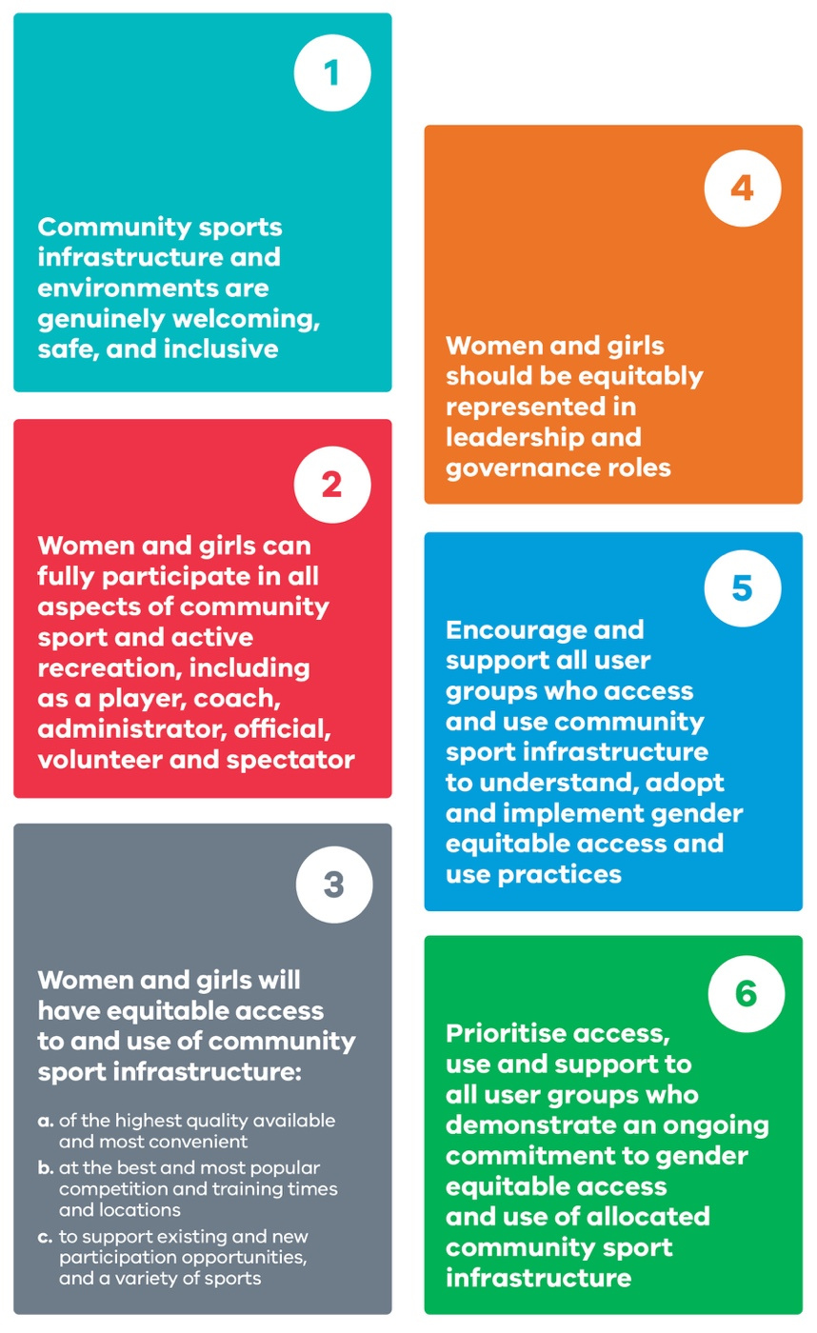

7. Compliance and Monitoring

Actions
[insert name of your organisation] commits to undertake a GIA on all current community sports infrastructure access and use policies and processes, and to consider opportunities to strengthen gender equitable access and use of community sports facilities in alignment with the Fair Access Principles.
If the process of assessing current policies and processes identifies opportunities to develop or strengthen gender equitable access and use of community sports facilities in alignment with the Fair Access Principles, [insert name of your organisation] commits to developing and adopting a locally relevant gender equitable access and use policy and action plan no later than 1 October 2024.
[insert name of your organisation] acknowledges that the requirement to have a gender equitable access and use policy and action plan (or equivalent) in place, and the ability to demonstrate progress against that policy and action plan (or equivalent), will form part of the eligibility criteria for Victorian Government funding programs relating to community sports infrastructure from 1 July 2024.
[Insert name of your organisation] has also identified specific actions to progress gender equitable access and use of community sports infrastructure in its Fair Access Action Plan.

Responsibility
[Insert relevant committee or position such as Manager Sport and Recreation] is responsible for implementing [insert name of your organisation]’s Fair Access Policy. Management personnel, staff, volunteers, and stakeholders (for example SSAs and RSAs) at [insert name of your organisation] have a shared responsibility to support the policy, as outlined in the table below.
Role | Responsibility
Local Government - CEO and Executive, or  Land Management Group – President or Chair | - To promote a gender-aware and gender-responsive culture and community and championing the Fair Access Policy.  - To promote, encourage and facilitate the achievement of gender equality and improvement in the status of women and girls in sport and active recreation.  [Insert other responsibilities in line with your organisation’s preference]
Local Government - Sport and Recreation Managers or similar, or  Land Management Group – nominated committee member/s | - Lead the review of sport and recreation policies and process  - Develop and adopt gender equitable access and use policies  - To communicate policy updates to all staff and members  - To monitor compliance and issues  - To promote, encourage and facilitate the achievement of gender equality and improvement in the status of women and girls  - Support the undertaking of Gender Impact Assessment and submission of progress reports as per the Gender Equality Act 2020 obligations  [Insert other responsibilities in line with your organisation’s preference]
Local Government – accountable Officer for the Gender Equality Act or similar, or  Land Management Group – nominated committee member/s | - Support the review of sport and recreation policies and processes  - Support the formal adoption process of a new or revised gender equitable policies  - Undertake Gender Impact Assessment and submission of progress reports as per the Gender Equality Act 2020 obligations  [Insert other responsibilities in line with your organisation’s preference]
Local Government - Sport and Recreation Officers, or  Land Management Group – nominated committee member/s | To communicate and educate sport and recreation infrastructure user groups and users.  [Insert other responsibilities in line with your organisation’s preference]
Local Government – all staff, or  Land Management Groups – all committee members/volunteers | To adhere to and communicate the policy when required.  To attend training / awareness programs.  [Insert other responsibilities in line with your organisation’s preference]

For further information related to this Policy see:
- Gender Equality Act 2020 (Vic)
- Local Government Act 2020 (Vic)
- Equal Opportunity Act 2010 (Vic)

8. Definitions

Committees of Management
For the purposes of this document, refers to committees appointed by the Department of Land, Water, Environment and Planning under the Crown Land (Reserves) Act 1978 to manage recreation reserves where community sport training and games are held.

Community Sports Infrastructure
Publicly owned local, rural, regional, or state level sport and recreation infrastructure operated and maintained primarily for the purpose of facilitating community sport activities, including sporting grounds, surfaces, facilities, and pavilions.

Gender
How you understand who you are and how you interact with other people. Many people understand their gender as being a man or woman. Some people understand their gender as a mix of these or neither. A person’s gender and their expression of their gender can be shown in different ways, such as through behaviour or physical appearance.

Gender diverse
An umbrella term for a range of genders expressed in different ways. Gender diverse people use many terms to describe themselves. Language in this area is dynamic, particularly among young people, who are more likely to describe themselves as non-binary.

Gender equality
The equal rights, responsibilities and opportunities of women, men and trans and gender-diverse people. Equality does not mean that women, men and trans and gender diverse people will become the same but that their rights, responsibilities, and opportunities will not depend on their gender.

Gender equity
The provision of fairness and justice in the distribution of benefits and responsibilities based on gender. The concept recognises that people may have different needs and power related to their gender and these differences should be identified and addressed in a manner that rectifies gender related imbalances.

Gender Impact Assessment, or GIA
A requirement under the Gender Equality Act 2020 to be carried out on policies, programs and services which have a direct and significant impact on the public. The assessment must evaluate the effects that a policy, program or service may have on people of different genders.

Public land management groups
For the purposes of this document, are the Committees of Management appointed under the Crown Land (Reserves) Act 1978 and responsible for the management of recreation reserves where community sport training and games are held.

Transgender, or trans
Someone whose gender does not only algin with the one assigned at birth. Not all trans people will use this term to describe themselves.

9. Policy Authorisation
Save all versions of this policy in [insert LGA or public landowner group] official records management system.

- Issuing group / branch:
- Date effective:
- Next review:
- Reference:

For further information please contact: [relevant contact in LGA or public landowner group]

10. Addendum: The Fair Access Action Plan Template

Principle 1: Community sports infrastructure and environments are genuinely welcoming, safe, and inclusive.
Actions to achieve progress | Timeframe | Responsibility | Indicator of Success

Principle 2: Women and girls can fully participate in all aspects of community sport and active recreation, including as a player, coach, administrator, official, volunteer and spectator.
Actions to achieve progress | Timeframe | Responsibility | Indicator of Success

Principle 3: Women and girls will have equitable access to and use of community sport infrastructure:
- of the highest quality available and most convenient
- at the best and most popular competition and training times and locations
- to support existing and new participation opportunities, and a variety of sports.
Actions to achieve progress | Timeframe | Responsibility | Indicator of Success

Principle 4: Women and girls should be equitably represented in leadership and governance roles.
Actions to achieve progress | Timeframe | Responsibility | Indicator of Success

Principle 5: Encourage and support all user groups who access and use community sport infrastructure to understand, adopt and implement gender equitable access and use practices.
Actions to achieve progress | Timeframe | Responsibility | Indicator of Success

Principle 6: Prioritise access, use and support to all user groups who demonstrate an on-going commitment to gender equitable access and use of allocated community sport infrastructure.
Actions to achieve progress | Timeframe | Responsibility | Indicator of Success

